Zero norm

Intro

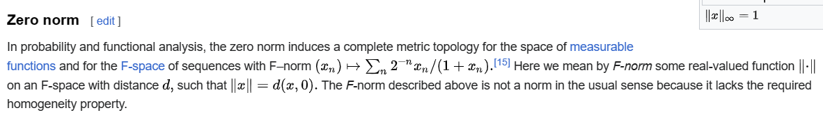

Ref

See zero norm subsection in Examples section in Wiki,

[Norm (mathematics) - Wikipedia](https://en.wikipedia.org/wiki/Norm_(mathematics)#Equivalent_norms)